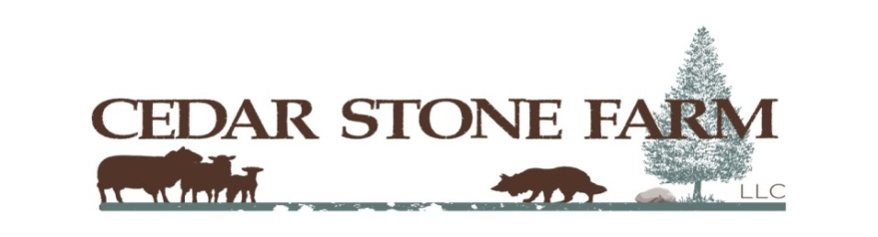**INFORMATION PAGE – Please Retain for Future Reference**

**STOCK DOG TRIAL**

**August 8, 9, 10, 11, 2024**

**N3909 Airport Rd., Cambridge, Wisconsin 53523**

**JUDGE: LYLE LAD**

**USBCHA Sanctioned 3 Open and 3 Nursery Classes**

**Open:** 3 Runs $60.00 per run / per dog

**Nursery:** 3 Runs $50.00 per run / per dog

**Pro-Novice:** 2 Runs $50.00 per run / per dog. **Full Cross Drive, No Shed**

**Ranch:** 2 Runs $40.00 per run / per dog. **One Leg Drive.** Separate placings for Open & Novice handlers.

**Novice:** 2 Runs $40.00 per run / per dog. **One Leg Wear**

**Class Schedule: Thursday:** Nursery 1 Handler’s Meeting at 8:00 a.m., Pro-Novice 1, Pro-Novice 2,

Nursery 2

**Friday:** 8:00 a.m. Nursery 3, Open 1, start Open 2 if time allows

**Saturday:** 8:00 a.m. Open 2, Start Open 3

**Sunday:** 8:00 a.m. Complete Open 3, Ranch, Novice

Start times are subject to change due to class size or weather delays.

**ENTRIES OPEN May 22, 2024 and will remain open until the trial is filled. Checks will be cashed on June 30, 2024. No refunds after June 30, 2024.**

**Make checks payable to**: Cedar Stone Farm, LLC. **and mail to Cedar Stone Farm, N3909 Airport Rd., Cambridge, WI 53523.** A Third dog may be accepted in all classes if numbers permit (include separate check). No entries accepted without full payment.

Please clean up after your dog/s. No dogs allowed on the trial field before or after trial hours.

Food and beverages will not be available on grounds throughout the trial unless we can find a food truck or a group willing to set up a food stand. There are a variety of sit down and drive through pick up restaurants in the area. Ample parking and RV/camping space is available on site. Sorry, no hookups. Since there is little to no shade, please plan accordingly. Pet friendly hotels within 30 minutes of the trial field can be found in Fort Atkinson, Jefferson, Lake Mills, Johnson Creek, Whitewater, Janesville, and Madison, Wisconsin. There are also a number of Air B&B’s in the area. Please inquire about pet policies and any fees when making contact as there are changes from year to year.

**MIDWEST TRIFECTA: This is the third trial in a series of three trials, three weekends in a row (Whistle & Crook, Nippersink and Cedar Stone Farm). Add Open scores for each dog from each of the 3 trials.**

**\*\*\* $1,000 Grand Prize High-Point Dog. $600 Reserve High Point Dog \*\*\***

Merry Russell

Cedar Stone Farm

Please direct any questions or inquiries to Merry Russell 920-222-0348 mruss75@gmail.com

**ENTRY FORM**

**STOCK DOG TRIAL**

**August 8, 9, 10, 11, 2024**

**N3909 Airport Rd., Cambridge, Wisconsin 53523**

**JUDGE: LYLE LAD**

**LAST DAY FOR WITHDRAWAL AND REFUND IS June 30, 2024**

NAME: ____________________________________________________ PHONE: ________________________

ADDRESS: ______________________________________________________________________________________

CITY: _____________________________________________ STATE _______ ZIP CODE __________________

E-MAIL ADDRESS: ________________________________________________________________________________

**Cost per Run: Open 1, 2, & 3 $60.00 each, Nursery 1, 2, & 3 $50.00 each, Pro-Novice 1 & 2 $50.00 each**

**Ranch 1 & 2 $40.00 each, Novice 1 & 2 $40.00 each**

**PLEASE SEND SEPARATE ENTRY FORM AND CHECK FOR 3rd DOGS**

Owner/Handler Dog’s Name Class Amount

___________________________________ ______________________ _______________ $ ____________

___________________________________ ______________________ _______________ $ ____________

___________________________________ ______________________ _______________ $ ____________

___________________________________ ______________________ _______________ $ ____________

___________________________________ ______________________ _______________ $ ____________

___________________________________ ______________________ _______________ $ ____________

**Total $ ____________**

In consideration that I will be participating in the Cedar Stone Farm Stock Dog trials, I do hereby agree to pay for all damages caused by myself, my family, my property, my dogs or dogs under my supervision. I also agree that the owners of the property (Cedar Stone Farm, LLC), its owners, Merry Russell and Richard Anderson, and owners of the livestock (Big Yellow Boots Stock Dogs) John & Hixie Wentz, any family member, judge, set out, or volunteer, will not be held liable in the event of any personal injury, illness or damages to me, my dogs, dogs under my supervision or my property. I also agree to pay, at the time of occurrence, the shepherd’s value ($300) for any sheep damaged by my dog or any dog under my supervision. My signature below consents and agrees to these conditions.

SIGNATURE ______________________________________________________________ DATE _____________________

Please direct any questions or inquiries to Merry Russell [mruss75@gmail.com](mailto:mruss75@gmail.com) 920-222-0348

ENTRIES OPEN MAY 22, 2024 AND WILL REMAIN OPEN UNTIL TRIAL IS FILLED.

**LAST DAY FOR WITHDRAWAL AND REFUND IS June 30, 2024**